|  |  |
| --- | --- |
| **ID** | Registration_Err_01 |
| **Server Name** | http://localhost:7777/portalserver/banamex-cards-es/register-nonbancanet |
| **UI Error Message** | Verifica que la informacion sea correcta |
| **BackBase Error Response Body** | {"errorCode": "401",  "errorType": "INVALID_CARD",  "details" : "Invalid Card Details"} |
| **APIm Error Response Body** | { "code": "invalidCard",      "details": "The Card details entered are invalid",      "type": "ERROR" } |
| **Root Cause** | Information received is invalid |
| **Additional Information (if any)** |  |
| **Screenshot** | Below |

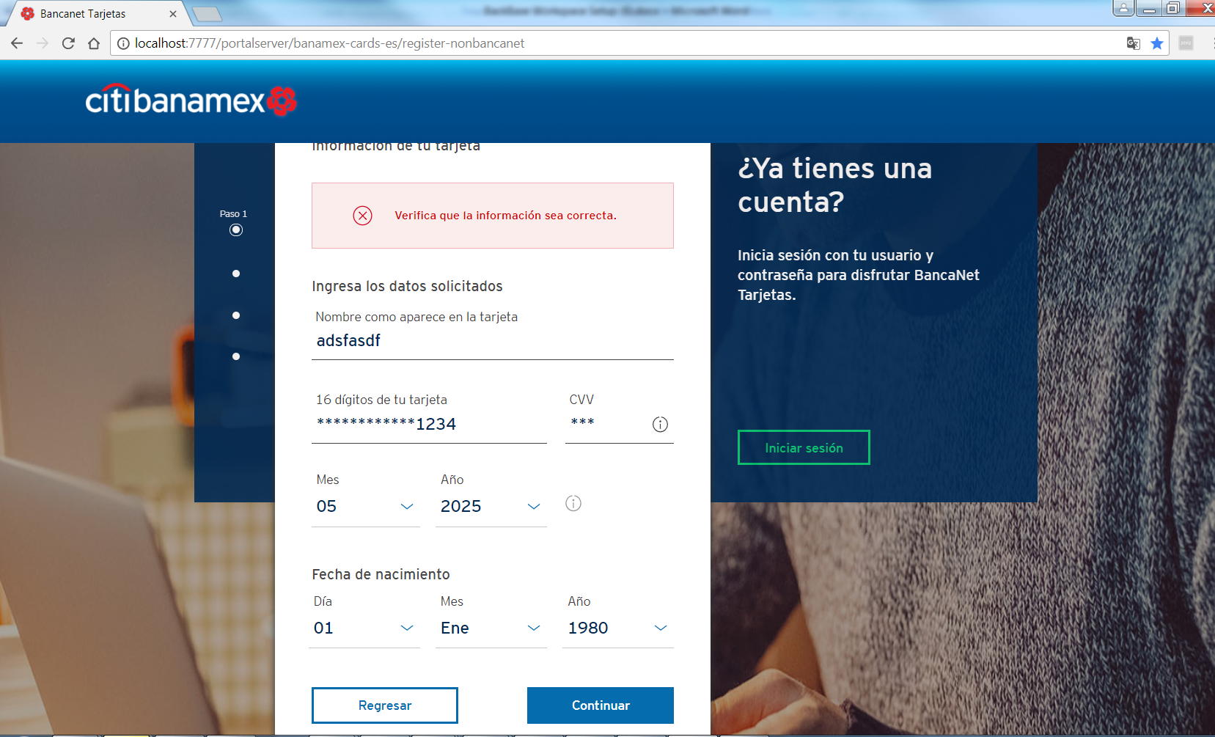

|  |  |
| --- | --- |
| **ID** | Registration_Err_02 |
| **Server Name** | http://localhost:7777/portalserver/banamex-cards-es/register-nonbancanet |
| **UI Error Message** | En este momento no podemos completar tu solicitud. Inténtalo más tarde. |
| **BackBase Error Response Body** | {"errorCode": "500",  "errorType": "TECHNICAL_DIFFICULTY",  "details" : "Technical Difficulty"} |
| **APIm Error Response Body** | {      "type": "error",      "code": "serverUnavailable",      "details": "The request failed due to an internal error/server unavailability",      "  } |
| **Root Cause** | * APIM server is down * Status from APIM is not a valid scenario possible error en APIM |
| **Additional Information (if any)** |  |
| **Screenshot** | Below |

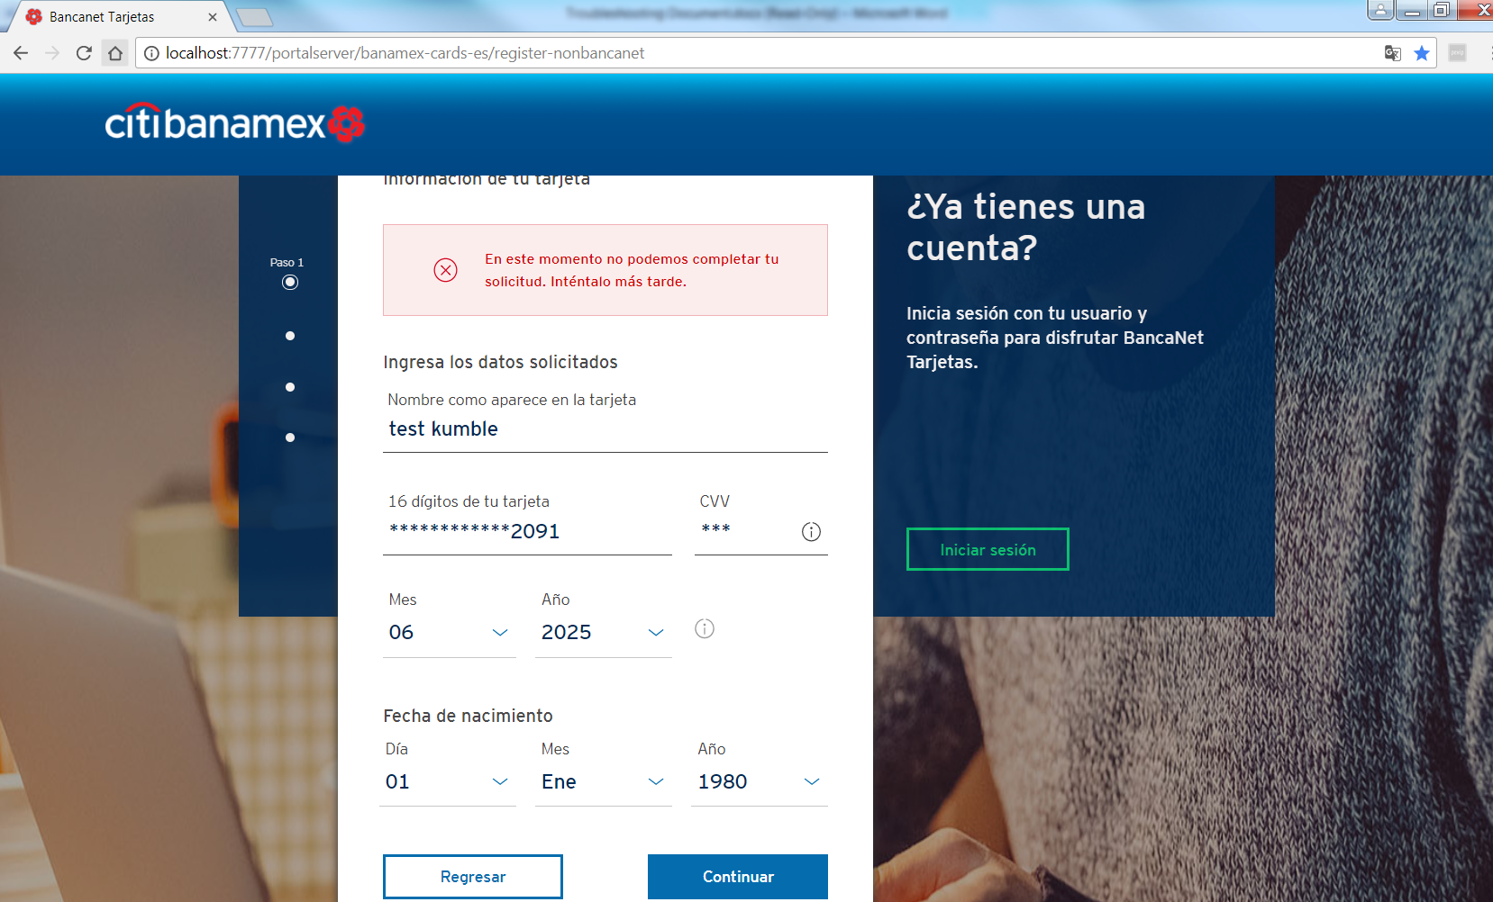

|  |  |
| --- | --- |
| **ID** | Registration _Err_03 |
| **Server Name** | http://localhost:7777/portalserver/banamex-cards-es/register-nonbancanet |
| **UI Error Message** | Hemos identificado que ya estas registrado en BancaNet Tarjetas, selecciona continuar para iniciar sesión. |
| **BackBase Error Response Body** | {"errorCode": "401",  "errorType": "CARD_REGISTERED",  "details" : "Card Alredy registered"} |
| **APIm Error Response Body** | {      "validCard": true,      "ccsCardRegistry": true,      "cardTypeIndicator": "P",      "customerRelationshipID": "0000000000082480155",      "electronicAccess": false,      "cardBlockResponse": {          "tempBlock": false,          "cardBlockStatusCode": null,          "accountBlockStatusCode1": null,          "accountBlockStatusCode2": null      },      "cardErrorMessage": "",      "cardErrorCode": "0"  } |
| **Root Cause** | User has enter a card already registered |
| **Additional Information (if any)** |  |
| **Screenshot** | Below |

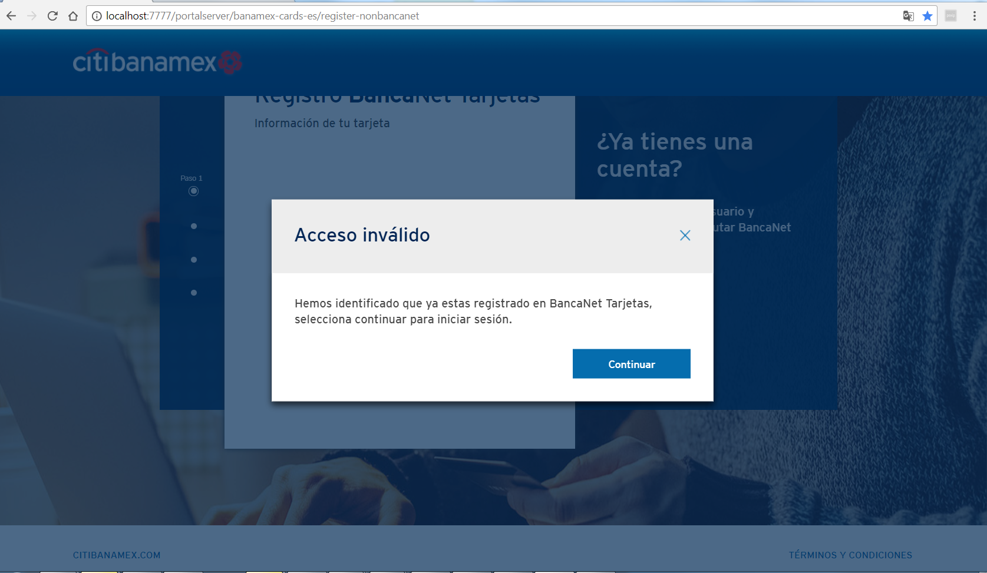

|  |  |
| --- | --- |
| **ID** | Registration _Err_04 |
| **Server Name** | http://localhost:7777/portalserver/banamex-cards-es/register-nonbancanet |
| **UI Error Message** | Hemos identificado que ya estas registrado en BancaNet Tarjetas, selecciona continuar para iniciar sesión. |
| **BackBase Error Response Body** | {"errorCode": "401",  "errorType": "CARD_LOST"} |
| **APIm Error Response Body** | {      "validCard": true,      "ccsCardRegistry": true,      "cardTypeIndicator": "P",      "customerRelationshipID": "0000000000082480155",      "electronicAccess": false,      "cardBlockResponse": {          "tempBlock": false,          "cardBlockStatusCode": L,          "accountBlockStatusCode1": null,          "accountBlockStatusCode2": null      },      "cardErrorMessage": "",      "cardErrorCode": "0"  } |
| **Root Cause** | User has enter a card with status lost |
| **Additional Information (if any)** |  |
| **Screenshot** | Below |

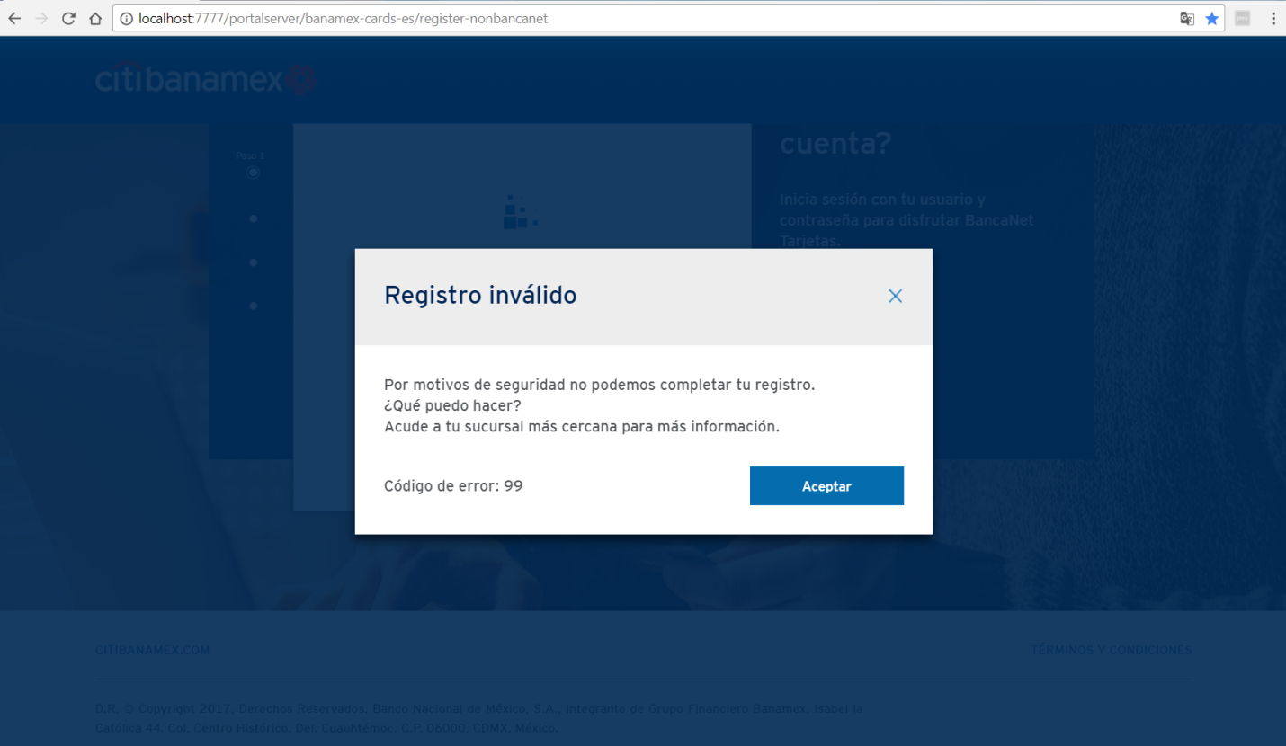

|  |  |
| --- | --- |
| **ID** | Registration _Err_05 |
| **Server Name** | http://localhost:7777/portalserver/banamex-cards-es/register-nonbancanet |
| **UI Error Message** | Hemos identificado que ya estas registrado en BancaNet Tarjetas, selecciona continuar para iniciar sesión. |
| **BackBase Error Response Body** | {"errorCode": "401",  "errorType": "CARD_STOLEN"} |
| **APIm Error Response Body** | {      "validCard": true,      "ccsCardRegistry": true,      "cardTypeIndicator": "P",      "customerRelationshipID": "0000000000082480155",      "electronicAccess": false,      "cardBlockResponse": {          "tempBlock": false,          "cardBlockStatusCode": S,          "accountBlockStatusCode1": null,          "accountBlockStatusCode2": null      },      "cardErrorMessage": "",      "cardErrorCode": "0"  } |
| **Root Cause** | User has enter a card with status stolen |
| **Additional Information (if any)** |  |
| **Screenshot** | Below |



|  |  |
| --- | --- |
| **ID** | Registration _Err_06 |
| **Server Name** | http://localhost:7777/portalserver/banamex-cards-es/register-nonbancanet |
| **UI Error Message** | Hemos identificado que ya estas registrado en BancaNet Tarjetas, selecciona continuar para iniciar sesión. |
| **BackBase Error Response Body** | {"errorCode": "401",  "errorType": "CARD_BLOCK"} |
| **APIm Error Response Body** | {      "validCard": true,      "ccsCardRegistry": true,      "cardTypeIndicator": "P",      "customerRelationshipID": "0000000000082480155",      "electronicAccess": false,      "cardBlockResponse": {          "tempBlock": false,          "cardBlockStatusCode": true,          "accountBlockStatusCode1": null,          "accountBlockStatusCode2": null      },      "cardErrorMessage": "",      "cardErrorCode": "0"  } |
| **Root Cause** | User has enter a card blocked |
| **Additional Information (if any)** |  |
| **Screenshot** | Below |



|  |  |
| --- | --- |
| **ID** | Registration_NIP_Err_01 |
| **Server Name** | http://localhost:7777/portalserver/banamex-cards-es/register-nonbancanet |
| **UI Error Message** | Inténtalo de nuevo. |
| **BackBase Error Response Body** | {"errorCode":"401",  "errorType":"INVALID_PIN",  "validPin":false} |
| **APIm Error Response Body** | {      "OAFL3519OperationResponse": {          "pinValidationResponse": {              "responseHeader": {                  "responseMessageId": 3519,                  "responseVersionNumber": 10,                  "responseTerminalId": "00000000MX",                  "responseUserdId": "RASWK"              },              "responseDateTime": {                  "responseDate": 170058,                  "responseTime": 0              },              "responseCode": 0,              "responseMoreInd": "N",              "responseFlag": "R",              "responseFormat": 1,              "responseReturnCode": "1",              "responseReturnMessage": "INVALID PIN",              "responseInvIcardTries": 0          }      }  } |
| **Root Cause** | Invalid pin entered |
| **Additional Information (if any)** |  |
| **Screenshot** | Below |

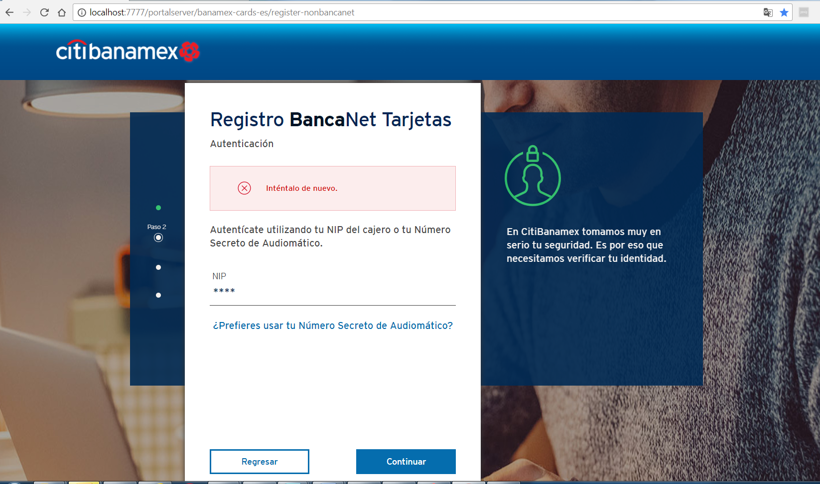

|  |  |
| --- | --- |
| **ID** | Registration_NIP_Err_02 |
| **Server Name** | http://localhost:7777/portalserver/banamex-cards-es/register-nonbancanet |
| **UI Error Message** | En este momento no podemos completar tu solicitud. Inténtalo más tarde. |
| **BackBase Error Response Body** | {"errorCode": "401",  "errorType": "INVALID_APPLICATION_CONTEXT",  "details" : "Invalid Application Context"} |
| **APIm Error Response Body** | N/A |
| **Root Cause** | User has reach inactivity time limit |
| **Additional Information (if any)** | Invalid application context happens reached inactivity time limit |
| **Screenshot** | Below |

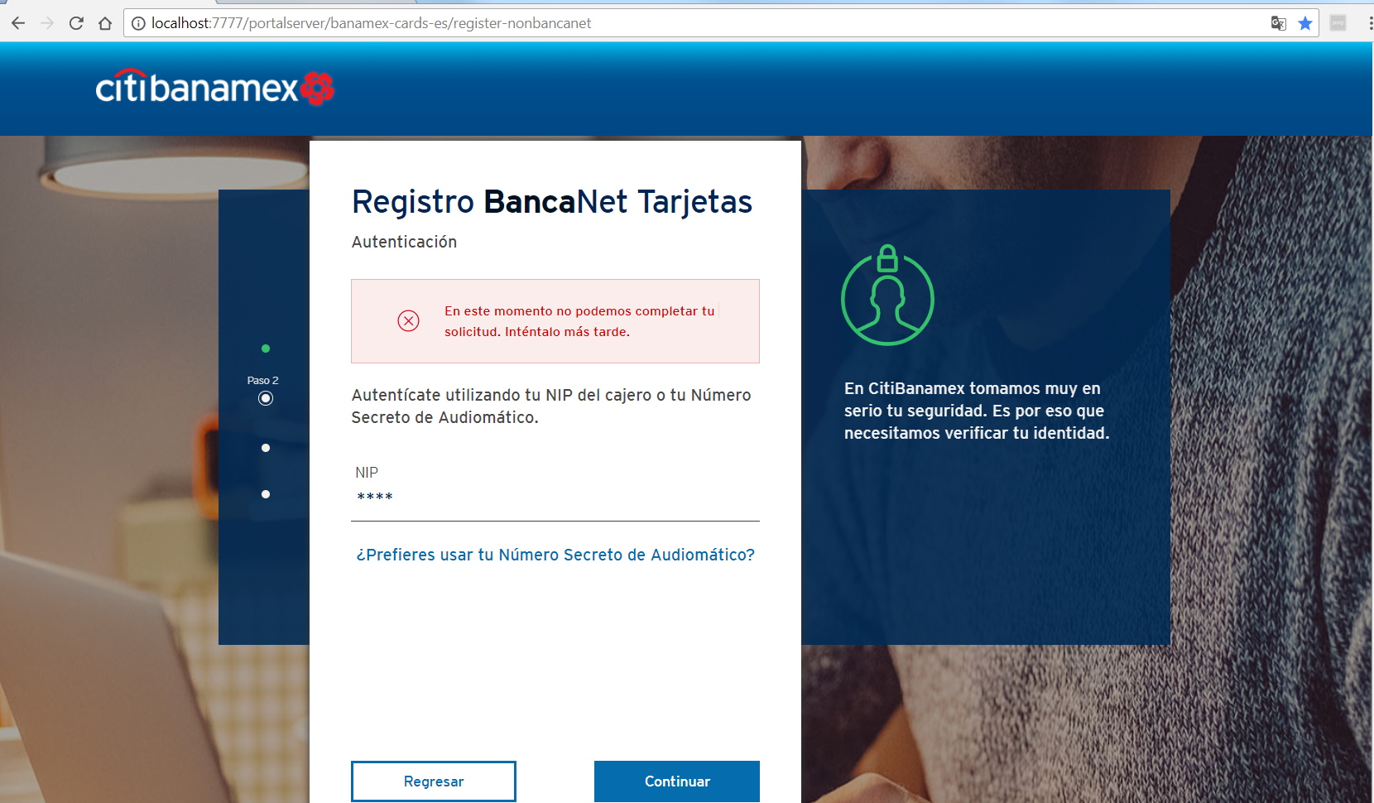

|  |  |
| --- | --- |
| **ID** | Registration_NIP_Err_03 |
| **Server Name** | http://localhost:7777/portalserver/banamex-cards-es/register-nonbancanet |
| **UI Error Message** | En este momento no podemos completar tu solicitud. Inténtalo más tarde. |
| **BackBase Error Response Body** | {"errorCode": "500",  "errorType": "TECHNICAL_DIFFICULTY",  "details" : "Technical Difficulty"} |
| **APIm Error Response Body** | { "type": "error",      "code": "serverUnavailable",      "details": "The request failed due to an internal error/server unavailability"} |
| **Root Cause** | * APIM server is down * Status from APIM is not a valid scenario possible error en APIM |
| **Additional Information (if any)** |  |
| **Screenshot** | Below |



|  |  |
| --- | --- |
| **ID** | Registration_phone_Err_01 |
| **Server Name** | http://localhost:7777/portalserver/banamex-cards-es/register-nonbancanet |
| **UI Error Message** | Verifica tu celular. |
| **BackBase Error Response Body** | {"errorCode": "401",  "errorType": "INVALID_APPLICATION_CONTEXT",  "details" : "Invalid Application Context"} |
| **APIm Error Response Body** | N/A |
| **Root Cause** | User has reach inactivity time limit |
| **Additional Information (if any)** | Invalid application context happens reached inactivity time limit |
| **Screenshot** | Below |

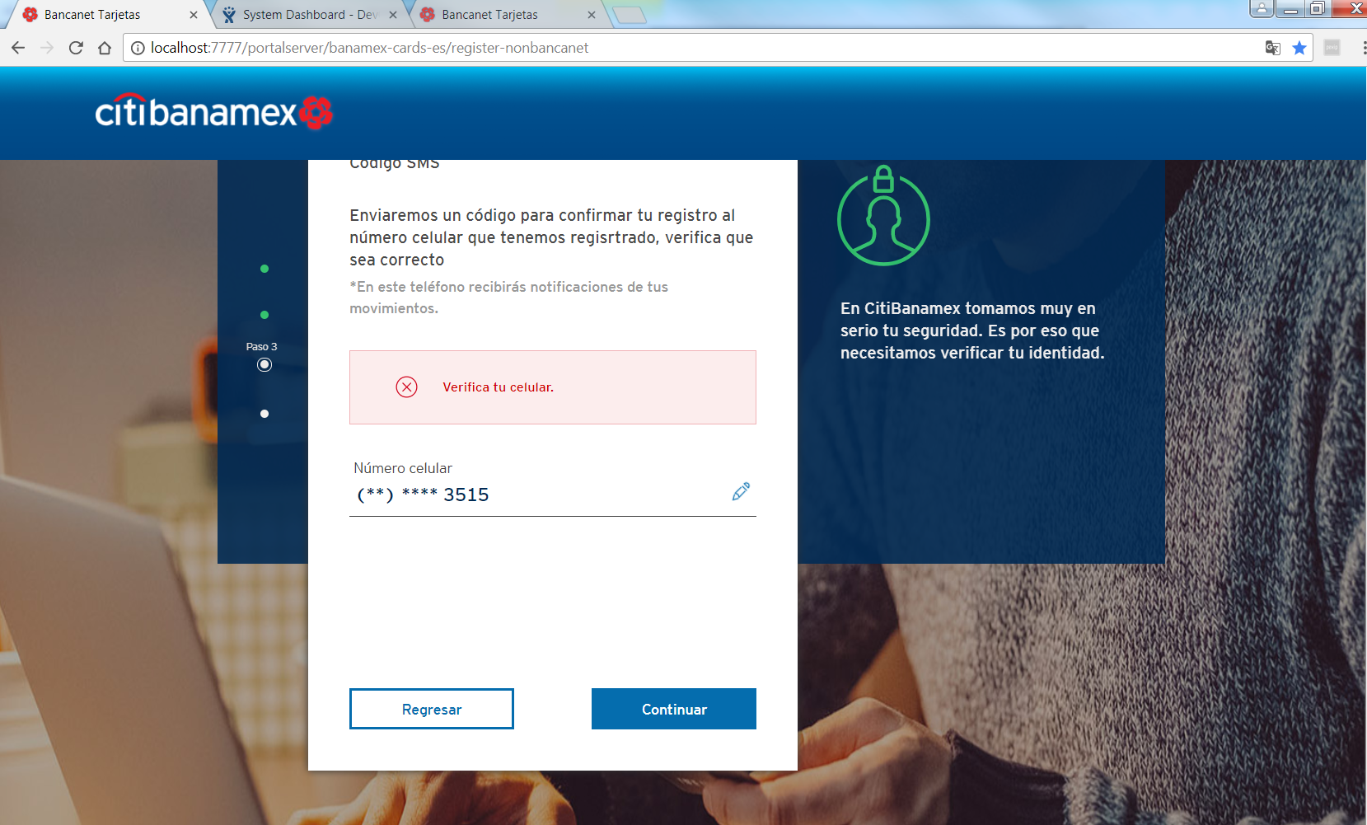

|  |  |
| --- | --- |
| **ID** | Registration_phone_Err_02 |
| **Server Name** | http://localhost:7777/portalserver/banamex-cards-es/register-nonbancanet |
| **UI Error Message** | En este momento no podemos completar tu solicitud. Inténtalo más tarde. |
| **BackBase Error Response Body** | {"errorCode": "500",  "errorType": "INTERNAL_SERVER_ERROR"} |
| **APIm Error Response Body** | {  "type": "error",      "code": "serverUnavailable",     "details": "The request failed due to an internal error/server unavailability"} |
| **Root Cause** | Status from APIM is not a valid scenario possible error en APIM |
| **Additional Information (if any)** |  |
| **Screenshot** | Below |

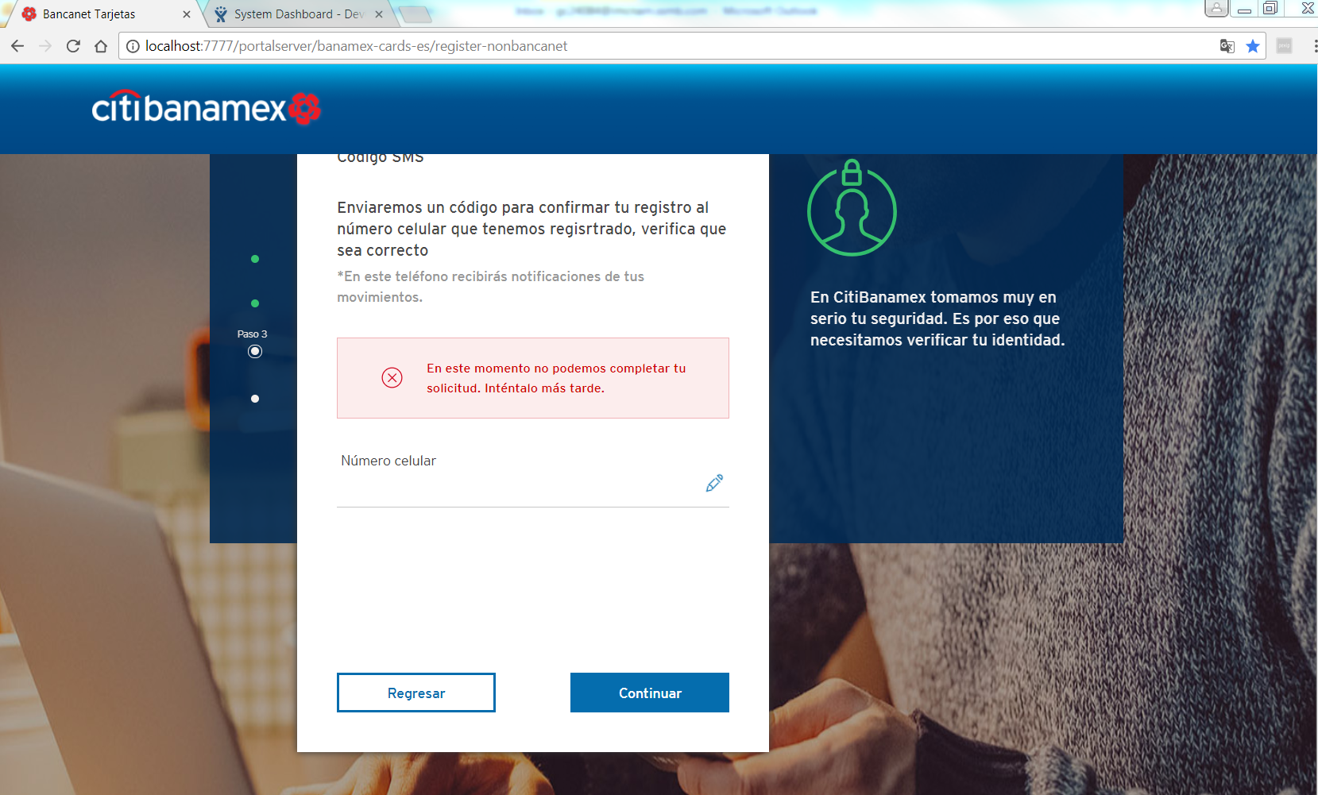

|  |  |
| --- | --- |
| **ID** | Registration_Cred_Err_01 |
| **Server Name** | http://localhost:7777/portalserver/banamex-cards-es/register-nonbancanet |
| **UI Error Message** | Este usuario ya esta registrado. Por favor, elige otro. |
| **BackBase Error Response Body** | {"errorCode": "401",  "errorType": "USERID_EXISTS "} |
| **APIm Error Response Body** | {      "code": "userIDRegistered",      "details": "User ID already registered",      "type": "ERROR"  } |
| **Root Cause** | User has enter a username already registered |
| **Additional Information (if any)** |  |
| **Screenshot** | Below |

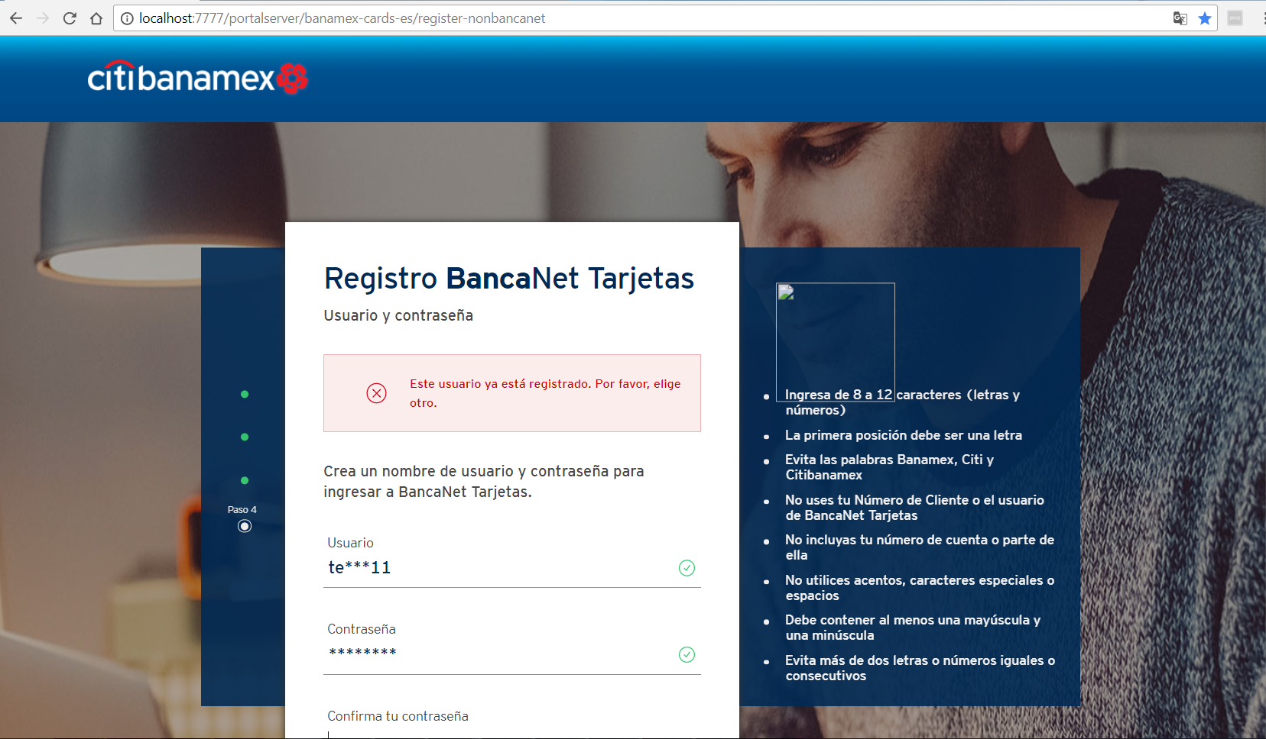

|  |  |
| --- | --- |
| **ID** | Registration_Cred_Err_02 |
| **Server Name** | http://localhost:7777/portalserver/banamex-cards-es/register-nonbancanet |
| **UI Error Message** | Lo sentimos.  En este momento no podemos completar tu registro. Recarga la página y si el problema persiste inténtalo más tarde |
| **BackBase Error Response Body** | {"errorCode": "401",  "errorType": "INVALID_APPLICATION_CONTEXT",  "details" : "Invalid Application Context"  } |
| **APIm Error Response Body** | N/A |
| **Root Cause** | User has reached inactivity time limit |
| **Additional Information (if any)** | Invalid application context happens reached inactivity time limit |
| **Screenshot** | Below |

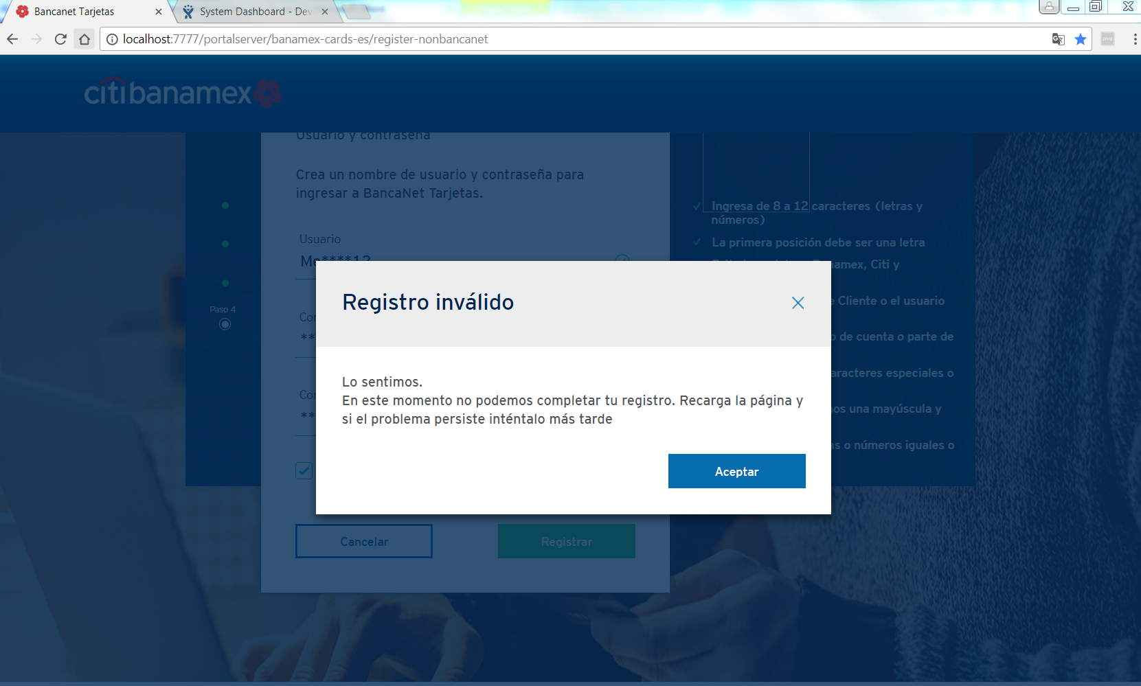

|  |  |
| --- | --- |
| **ID** | Registration_Cred_Err_03 |
| **Server Name** | http://localhost:7777/portalserver/banamex-cards-es/register-nonbancanet |
| **UI Error Message** | Lo sentimos.  En este momento no podemos completar tu registro. Recarga la página y si el problema persiste inténtalo más tarde |
| **BackBase Error Response Body** | {"errorCode": "500",  "errorType": "TECHNICAL_DIFFICULTY",  "details" : "Technical Difficulty"} |
| **APIm Error Response Body** | { "type": "error",      "code": "serverUnavailable",      "details": "The request failed due to an internal error/server unavailability"} |
| **Root Cause** | * APIM server is down * Status from APIM is not a valid scenario possible error en APIM |
| **Additional Information (if any)** |  |
| **Screenshot** | Below |



|  |  |
| --- | --- |
| **ID** | Registration_Cred_Err_04 |
| **Server Name** | http://localhost:7777/portalserver/banamex-cards-es/register-nonbancanet |
| **UI Error Message** | Lo sentimos.  En este momento no podemos completar tu registro. Recarga la página y si el problema persiste inténtalo más tarde |
| **BackBase Error Response Body** | {"errors" : [{"code" : 500, "eventId" : "ID-USTX15369L02211-55652-1511213032283-1-4445", "message" : "Unexpected server error occurred"}]} |
| **APIm Error Response Body** | { "type": "error",      "code": " Unexpected server error occurred " |
| **Root Cause** | Unexpected server error from APIM check APIM services |
| **Additional Information (if any)** |  |
| **Screenshot** | Below |

